Documentation:
Task 3/4 (Mitchell):
- Test A: HTML Injection (Unsafe Page):
- What the Screenshot Shows: HTML tags like <u> and <h1> were typed into the input field. The application printed the text, but it made the text underlined and massively large.
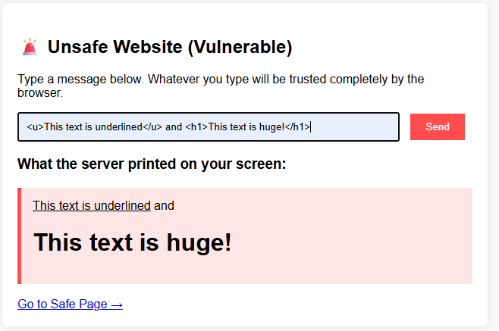
- The Cyber Concept: Lack of Input Validation. The server took the input and dropped it straight into the website's structure using raw Python string formatting (%s). Because there were no checks, the browser couldn't tell the difference between code written by the developer and text typed by a random user. It treated the input as instructions, letting an attacker change how the website looks.

- Test B: JavaScript Injection / Cross-Site Scripting (Unsafe Page):
- What the Screenshot Shows: A <script> tag containing an alert () function was typed into the input field. The moment the input was entered and sent, a pop-up window snapped onto the screen saying the user had been hacked.
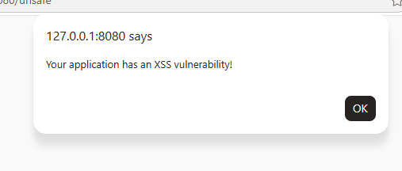
- The Cyber Concept: Stored/Reflected XSS (Cross-Site Scripting). This is an intermediate web vulnerability. Because the page didn't check the input, an executable programming code was successfully injected directly into another user's session. In a real-world chat application, a hacker could use this exact trick to silently steal session tokens, capture keystrokes, or redirect users to a fraudulent website.

3. Test C & D: The Defensive Fix (Safe Page with HTML & JS Injection)
- What the Screenshot Shows: The exact same HTML (<h1>) and JavaScript (<script>) code were typed the into the safe page box. Instead of breaking or creating pop-ups, the page safely displayed the text exactly as you wrote it, brackets and all.
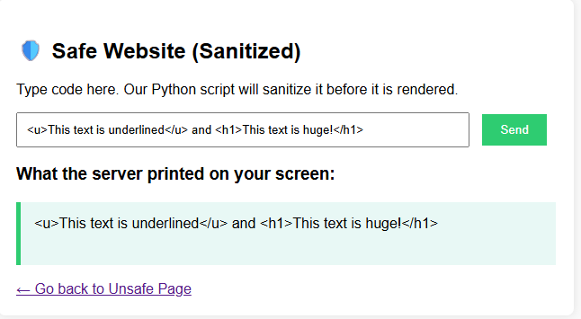
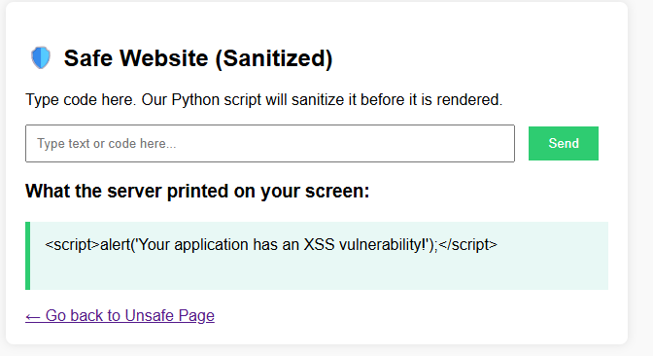

- The Cyber Concept: Input Sanitization & HTML Entity Encoding. This is the core defence mechanism. Before letting the input touch the screen, the Python backend intercepted the text and replaced dangerous control characters with HTML Entities:
Raw Character | Harmless HTML Entity | What the Browser Does
< | &lt; (Less Than) | Draws < visually but stops it from opening a code tag.
> | &gt; (Greater Than) | Draws > visually but stops it from closing a code tag.
& | &amp; | Prevents rendering bypasses.

Task 6 (Akshat):
Hash Cracker
A Python code that securely stores user messages using the bcrypt hashing library. The system allows the user to create an account, and hash the password, authenticate the login process, and using UTF 8, which stores user data in the JSON file.
Features
- Becrypt message hashing
- User Authentication
- JSON data storage
- Failed login tracking
- Account lockout protection
- Automatic hashing, and salting the hashed password
Libraries needed
- Becrypt
- Json
- Os
- Datetime
- Typing
Output
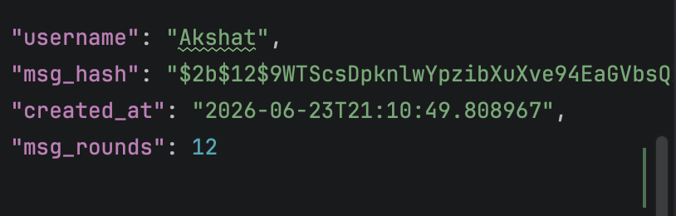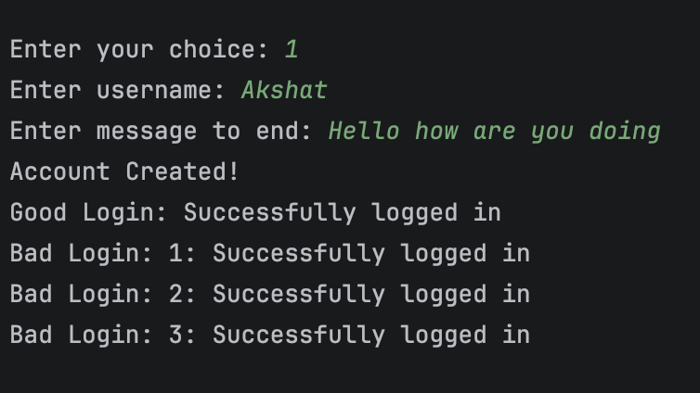
Backend
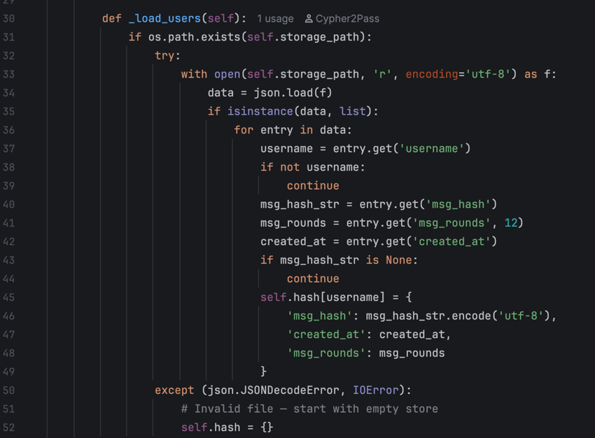
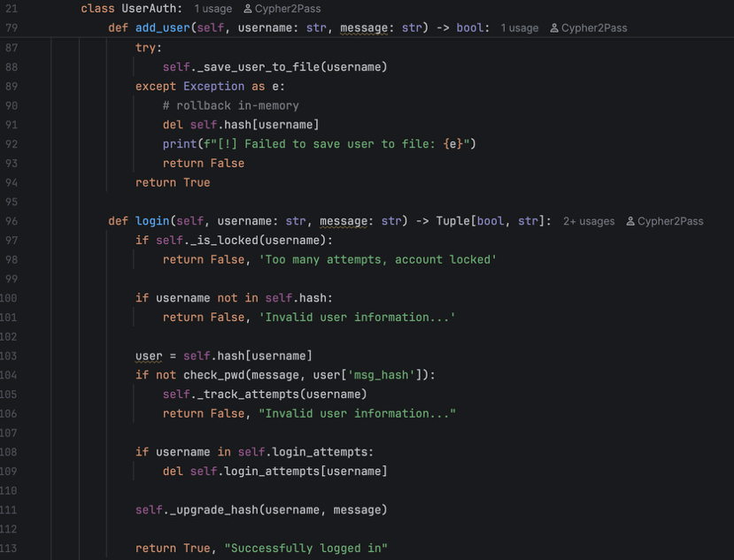
Problems:
- Hashing the messages will surely help to secure the messages, however if the other user receives the messages, it will receive the hashed message but not the original message, because hashing is a one-way process.
- However, I can use hashing to hash the password, as this will make sure the password that user enters gets hashed, and checks whether it is correct or not.
- Assign the message id with the hashing, as this will make sure that the message id is hashed correctly, so that the message will not be accessed by the hacker.

Task 7: Encryption and Decryption (Akshat)

The program uses the Fernet encryption from the cryptography library to securely encrypt and decrypt the messages.

Features
- Generates a secret encryption key
- Stores the key in a separate file
- Encrypts plaintext messages
- Decrypts encrypted messages
Libraries used:
- Cryptography.fernet

How It Works
- Generate a secret key.
- Save the key to secret.key.
- Encrypt a message using the key.
- Decrypt the message using the same key.
- Display the encrypted and decrypted messages.
Output
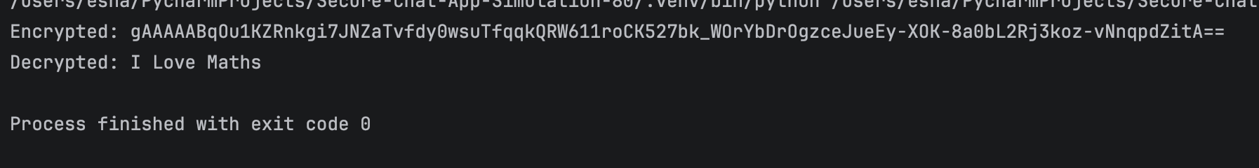
Backend

